T

A

N

Z

A

N

I

A

P

R

I

S

O

N

E

R

S

H

O

P

E

F

O

U

N

D

A

T

I

O

N

TPHF

R

e

s

t

o

r

e

&

E

m

p

o

w

e

r

W

e

l

f

a

r

e

S

e

r

v

i

c

e

s

**TANZANIA PRISONERS HOPE FOUNDATION**

**ANNUAL PERFORMANCE**

**REPORT -2022**

**PROJECT NAME: PRISONERS LIFE EMPOWERMENT IN SEGEREA PRISON**

Contacts:

Email Address: [support@tphf.or.tz](mailto:support@tphf.or.tz), [lucasmwimo@tphf.or.tz](mailto:lucasmwimo@tphf.or.tz) and [mwimolucas@gmail.com](mailto:mwimolucas@gmail.com)

Tel: +255 754 286 317

Website: <https://tphf.or.tz>

1. **INTRODUCTION**

In Tanzania, prisoners are facing a number of challenges including inadequate health care services, spiritual immorality, inadequate counseling services, limited clothing materials, inadequate legal aid, lack of official resettlement and rehabilitation services just to mention a few. The Government alone cannot solve all these challenges without involvement of individuals, community, NGOs and other actors. The TANZANIA PRISONERS HOPE FOUNDATION (TPHF) was established and registered in 19th April 2022, with registration number ooNGO/R/3102 to fill this gap, by mobilizing funds and materials from individuals, private and public agencies within and outside Tanzania. This will ultimately enable the organization to effectively provide prison support services as per objectives of its establishment. Our vision, mission and objectives are as follows;

**Vision:** To be an organization that endeavors to transform the prisoners’ and ex-prisoners’ lives, socially, morally and materially for their self-reliance.

**Mission:** To Promote and Rehabilitate the Welfare of prisoners and ex-prisoners in Tanzania.

**Objectives**

(i) To conduct counseling services to prisoners and ex-prisoners to be good citizens

(ii) To distribute spiritual and other reading materials for knowledge change.

(iii) To provide health care and sanitation services to complement government’s efforts in providing prisons’ welfare services.

(iv) To establish and promote the library services in some prisons

(v) To assist the reintegration of the ex-prisoners into the society particularly providing them with small capital for establishment of small scale enterprises such as farming, bricks making, gardening, carpentry, building, etc. depending on the knowledge gained while in prisons.

(vi) To facilitate the prisoners with the necessary body clothing materials, tooth paste, mattresses and other necessary requirements.

(vii) To provide justice and legal assistance particularly to children, women and people with special needs.

(viii) To design and implement projects that will enable prisoners and ex-prisoners to improve their living standards.

(ix) To facilitate resources mobilization to support prisoners and ex-prisoners.

(x) To liaise with other organizations and foundations in promoting and effecting the objectives of the Foundations.

Having been established in April, 2022, TPHF started to implement its project and activities in June 2022. The organization implemented one project known as “**PRISONERS LIFE EMPOWERMENT IN SEGEREA PRISON”**. This report highlights the performance of the project, activities performed and challenges that were encountered during the year 2022. The report also discusses the project and activities to be implemented during 2023 upon availability of funds.

**2.0 PROJECT ACHIEVEMENTS**

The project was designed to address some challenges facing prisoners and pre-trial detainees in Segerea prison which has the highest number of detainees and prisoners in Dar es Salaam region. Among the challenges facing the inmates include inadequate supply of sanitary pads, lack of milk to children born in prisons by the prisoner mothers and spread of communicable diseases and inadequate counselling services. The specific objective of this project was to “improve the prisoners’ welfare services at Segerea prison”. The expected outcomes of the project were as follows; (a) minimized spread of communicable diseases (b) improved hygienic conditions (c) improved healthcare services for children of women prisoners (d) minimized stress among prisoners and detainees. The four outcomes were all successfully attained after implementation of the project from June –December 2022 as indicated in the matrix below;

**MATRIX 1: Project Achievements**

|  |  |
| --- | --- |
| **OUTCOMES** | **IMPACTS** |
| Minimized spread of communicable diseases | The rate of skin diseases spread among detainees and prisoners was reduced after supply and application of laundry and washing soap. |
| Improved hygienic conditions | The general hygienic condition among inmates was improved after supply of laundry and washing soap. |
| Improved healthcare services for children of women prisoners | The health conditions of 8 children of women prisoners were improved following supply of lactogen milk. |
| Minimized stress among prisoners and detainees. | The stressful conditions among prisoners and detainees were reduced through counselling services. |

**3.0 ACTIVITIES CARRIED OUT**

The activities carried out during 2022 were related to provision of social services at Segerea prison. The TPHF management conducted a meeting with the head of Segerea prison in May 2022 to establish the critical requirements needed by prisoners and pre-trial detainees. Thereafter the budget was prepared and approved by the Board and General meetings to procure and distribute the following items to Segerea prison in June 2022;

**3.1 Procured one carton of Lactogen (No.1) milk for consumption by 8 children of women** **prisoners** whom their ages were below six months. This was expected to improve their health conditions and the plan was achieved at 100% as the health of children improved and there was children death reported during the year under review **(Figure 1).**

**3.2. Procured 288 sanitary pads that were distributed to 140 women prisoners.** It should be noted that Seregea prison is the only one that hosts women prisoners and detainees in Dar es Salaam region. The target was achieved at 100% and this improved their sanitary conditions and restored confidence during their menstruation periods **(Figure 1).**

**3.3 Purchased and distributed 5 cartons of washing and laundry soap** (Magadi) to 1,700 inmates as planned. As a result, the spread of skin diseases was eradicated due to body and clothes cleanness among inmates **(Figure 1).**

**3.4 Procured and supplied 250 shavers-** The target was achieved as per budget approval.

**3.**5. **Procured and supplied one unit of brand new flat TV screen**. Getting various local and international social and other media information is important to prisoners and security officers who are on duty. The TV screen was supplied on that basis and this helped inmates and security officers to access media information easily **(figure 1).**

**Figure 1: Some members of TPHF donating some items at Segerea Prison**

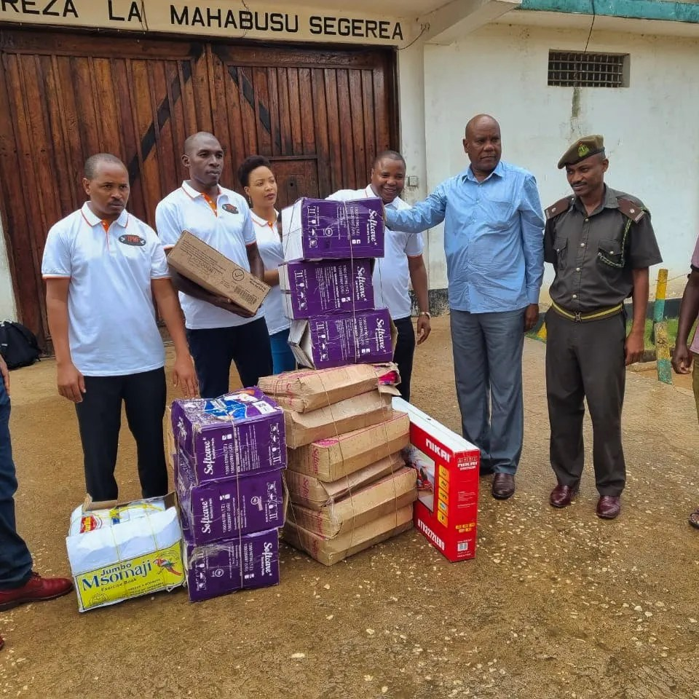

**Figure 1:** On 25th June 2022, Tanzania Prisoners Hope Foundation member visited the Segerea prison and donated sanitary pads, washing and laundry soaps, baby milk and a brand new TV set. A group photo of some of the TPHF members handing over the items to Head of Segerea prison, Senior Superintendent Hamis Alute Lissu.

**3.6.** **Provided counselling services to 1,800 prisoners and detainees at Segerea prison and 3 ex-prisoners**. Many prisoners and pre-trial detainees sees prisons as the hostile places and therefore becomes stressed. It was from this background that TPHF carried out a counselling service in Segerea prison where an experienced counselor counselled 1,800 inmates and they appreciated for service which was accompanied with distribution of soft drinks and bites during the counselling session (**Figure 2**)

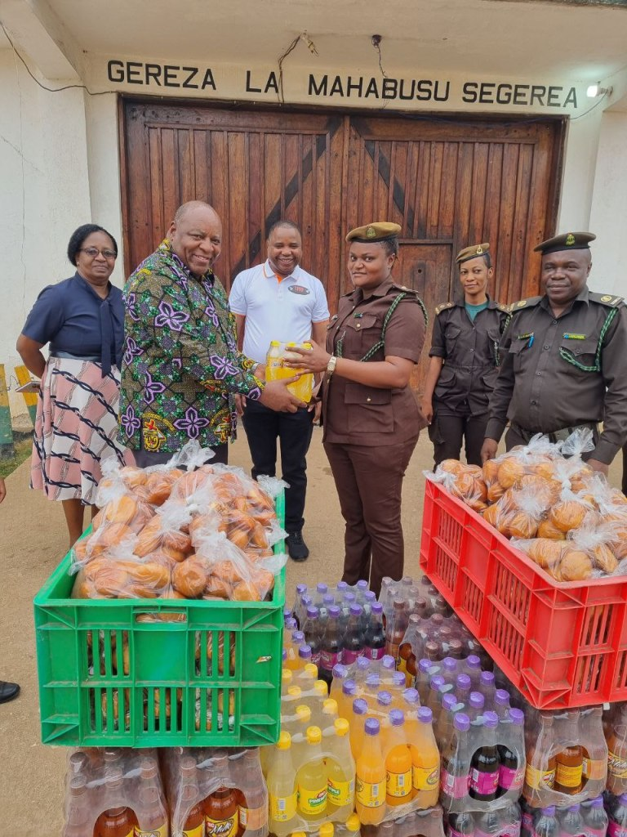

**Figure 2:** On 1st October 2022, TPHF conducted counseling session in the Segerea prison. Mr Ray Seng’enge (Left), a professional counselor handing over soft drinks and bites to the representative of Head of prisons at the Segerea Prison (right) to be distributed to 1,800 inmates during the counseling session. At the center is the CEO of TPHF, Mr Lucas Mwimo.

The CEO of TPHF also provided the counselling services to three former Segerea prison ex-prisoners on 13rd December, 2022 at Kibo Complex hotel situated at Tegeta, Kinondoni District, Dar es Salaam region. During the session, the ex-detainees were guided how best they can integrate with their families and communities after their release from Segerea prison, active participation in income generating activities to avoid re-offending and engagement to religious services. They were also provided with lunch and soft drinks **(Figure 3).**

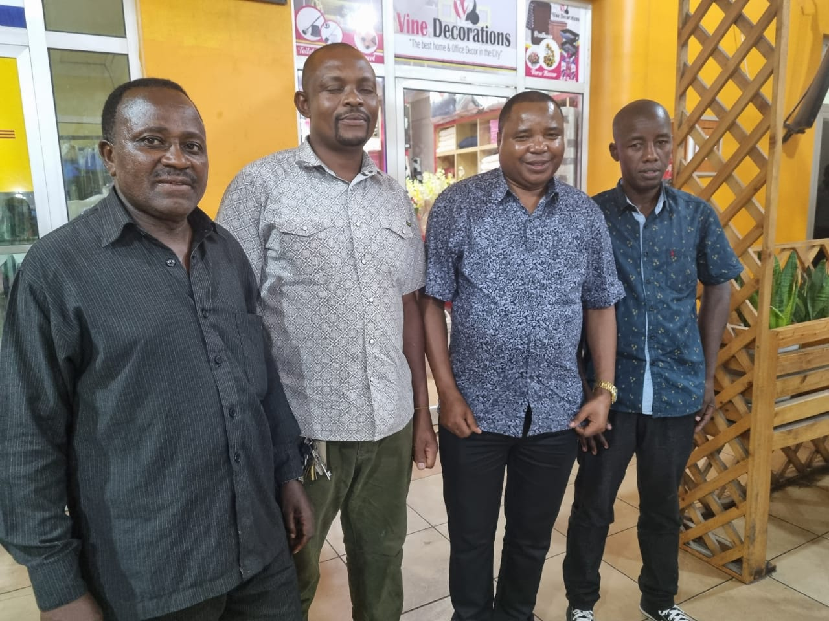

**Figure 3:** Pictured above from left to right are; Mr. Nkwama (ex-detainee), Mr. Osca (ex-detainee), Mr. Mwimo (CEO-TPHF) and Mr. Sebastian (ex-detainee) after counselling service at Kibo Complex Hotel in Tegeta.

1. **GOOD GOVERNANCE**

For the NGOs to prosper in executing its mandate, the good governance it needed. It was from this backdrop that, the TPHF general meeting approved the team of eight 8 experienced and dedicated Board Members with high academic qualifications to oversee and protect the image of the organization among other functions as stipulated in **Article 19** of the constitution. Out of 8 Board members, 5 of them have Master’s degree in different fields and worked in different public and private organizations. This enabled them to advise the organization on the proper way of budgeting and implementing the projects to attain the stipulated objectives. The eight board members with their brief CVs are attached as **appendix 1**. The organization has been conducting its Board and General meetings during the year as required by the Register of NGOs in the country as depicted in **Figure 4 and 5.**

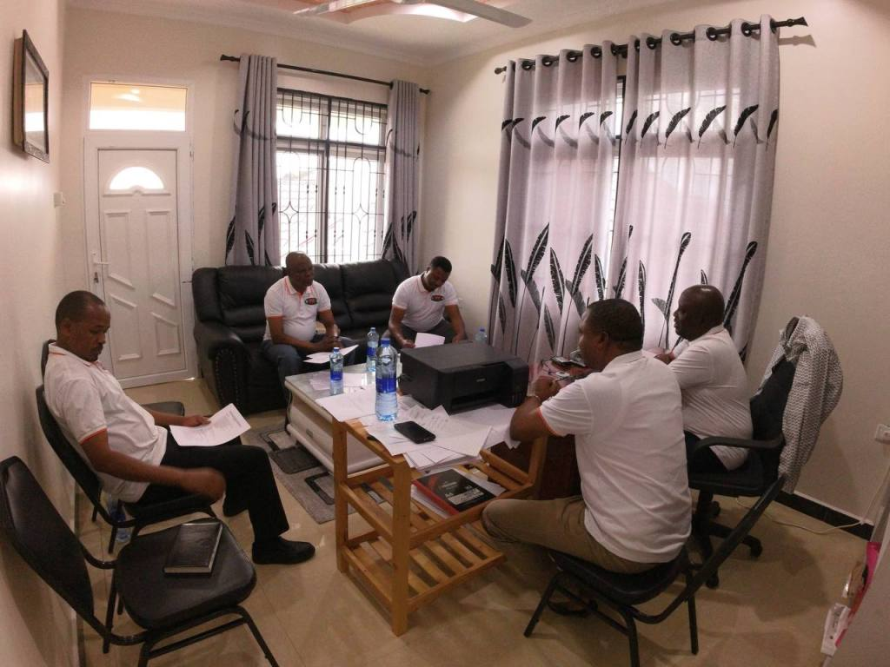

**Figure 4:** The Tanzania Prisoners Hope Foundation (TPHF) Board of Directors had a meeting on 10th September 2022 at TPHF Head Office – Kinyerezi, Mkuza Street, House No. 30 to discuss various issues relating to the performance of the organization and propose the way forward for the NGO. At the picture, Board Members discuss meeting proceedings under the chairmanship of Mr. Odimary Rushita.

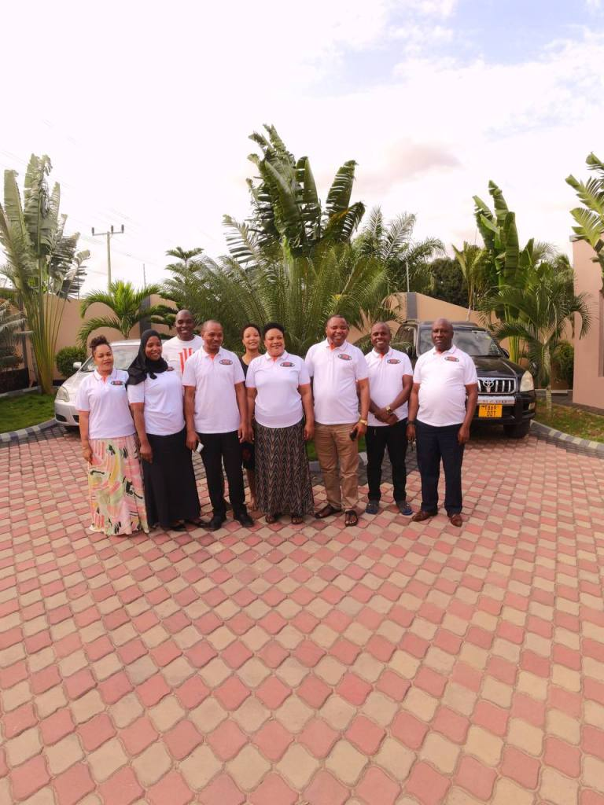

**Figure 5:** Some of the General Meeting members poses for a picture after their meeting at TPHF premises. From right to left (front line) are Odimary Rushita (Chaiman of the Board), Lupakisyo A. Mwambunga (Member), Lucas Mwimo (Chairperson & Board secretary), Gloria A. Kitiku (Treasurer& Board member), Mohamed Majengo Athuman (Executive Secretary and Board member), Shida A. Kitiku (Board Member), Rehema Hassan Jula (Member & Administrative manager), Renatus Moris Ambros (Member) and Mwanahamisi A. Kitiku (Member & Program manager).

The emergency Board and General meetings were held recently on 31/12/2022. Among other agenda, the meetings discussed and approved the quarterly and annual performance reports before uploading the same to NIS and distribution to other stakeholders as required by NGOs regulations.

1. **CHALLENGES AND HOW THEY WERE ADDRESSED**

The TPHF encountered the following challenges during the course of implementing its project;

1. Inadequate funds. The organization depended entirely on members’ fees and members’ donations to run its activities. There was no grant received from internal or external sources. This was also contributed by inadequate experience of writing credible project proposals and concept notes for donor support.
2. Inadequate knowledge and skills on writing the quarterly and annual performance reports among staff.
3. Lack of counselling skills, leading to hiring of counsellors from other organizations.

The TPHF used the following ways to address the challenges for improvement and widening the scope of its operations;

1. The organization continued to sensitize other stakeholders to support it through physical visits, telephone calls and use of social media like TPHF website <https://tphf.or.tz> and Facebook platforms. The Board members through its meeting held on 10th September 2022 also encouraged members to continue supporting the organization’s operations by contributing fees not less than TZS 50,000/= from January 2023.
2. The management team and managers of TPHF attended the seminars conducted by Open Civil Society Organizations (CSOs) Platform of Tanzania from October to December 2022. The management team and managers of TPHF attended the seminars conducted by Open Civil Society Organizations (CSOs) Platform of Tanzania from October to December 2022. The seminars on NGOs which were facilitated by CEO and Founder of CSOs Platform of Tanzania Mr. Ntimi exposed the participants on the following areas;

* How to operate the CSOs efficiently and productively.
* Importance of conducting Board and General meetings timely and related minutes and resolutions writing
* NGOs’ business transparency to abide with the government policies and regulations
* Format for writing and distribute the quarterly and annual performance reports to various stakeholders
* How to upload reports to NIS
* The NGOs funding opportunities
* preparation of financial reports and reconciliation
* Monitoring and Evaluation of the projects and handling of volunteers.
* Etc etc.

The TPHF is an active member of CSOs Platform of Tanzania.

1. The TPHF through Open CSOs of Tanzania has applied for volunteers from USA and other countries who shall work with TPHF staff for three months in 2023. One of the tasks of volunteers will be to build capacity to our staff particularly on counselling services skills and advise the organization on the reliable sources of grants. The volunteers will also share experience on best practices of handling NGOs affairs.

**5.0 THE WAY FORWARD**

In its Board and Annual General meetings held on 10th September 2022, the members approved two projects to be implemented during 2023 among other resolutions. The projects to be implemented upon availability of funds include;

1. **Addressing challenges facing ex-prisoners in Dar es Salaam region**
2. **Prisoners life empowerment scheme in Dar es Salaam region**

Following the gained experience and skills acquired from seminars conducted by Open CSOs Platform of Tanzania, the approved projects will be implemented smoothly during 2023 upon availability of funds. The TPHF plans to invite volunteers from USA and other countries to share their experience and impart more knowledge to our staff on counselling skills to prisoners and ex-prisoners. The volunteers and the Open CSOs Platform of Tanzania will also be consulted to advise the organization on the prospective donors to enable the organization implement its activities smoothly.

**6.0 CONCLUSION**

During the first year of its operations, the TPHF has solved some of challenges facing Segerea Prison albert the limited financial resources. During 2023 TPHF is committed to address some of challenges facing pre-trial detainees, prisoners and ex-prisoners in Dar es Salaam region after mobilization of funds and materials from individuals, private and public agencies within and outside Tanzania. To-date, there is no any NGO in the country which is dedicated to support the prisoners and ex-prisoners in the country. TPHF has been established to fill that gap and is committed to expand its services to other prisons outside Dar-es-Salaam region in future upon availability of funds.

**APPENDIX 1: LIST OF BOARD MEMBERS AND THEIR BRIEF CVs**

1. Mr. Odemari Nitunga Rushita- He is the first chairman of the Board of Directors TPHF since its establishment in April, 2022.  He is an experienced leader and currently works at Engineers Registration Board as Assistant Registrar (Director of Finance) since 2008 to-date. He is a Certified Public Accountant -CPA (T). Before joining the Board, he worked at CCT –WAMA, Christian Council of Tanzania as a Finance and Administrative Manager from 2000 to 2008. He holds MBA degree from ESAMI and Maastricht School of Management (MsM) Nairobi, Kenya Campus and Advanced Diploma in Accountancy (ADA) from the Institute of Finance Management, Dar-es-Salaam Tanzania.
2. Lucas Mwimo- CEO and secretary to the Board. Prior to TPHF, he worked with the Bank of Tanzania as an Economist for 32 years and 7 months and he retired as a Director-BOT Mtwara Branch in February 2022. While working with the Bank of Tanzania, he was seconded to the International Monetary Fund (IMF) – Office of the Resident Representative in Tanzania for 2 years (July 1997 to June 1999) as a Research Assistant charged with the implementation of IMF-supported programs in Tanzania. He holds a M.Sc. (Macro-economic Policy and Planning in Developing Countries) from the University of Bradford, United Kingdom and a B.A. (Economics) from the University of Dar es Salaam, Tanzania.
3. Mohamed Majengo Athuman- General Secretary –TPHF. Currently works as a School Quality Assurer - Ministry of Education Science and Technology (Kinondoni Municipality Division). He holds Master of Education in Administration, Planning and Policy Studies (MED - APPS) from OPEN UNIVERSITY OF TANZANIA (OUT).
4. Gloria Athumani Kitiku – She is a Treasurer- TPHF and an experienced business woman with a certificate in Agriculture and Livestock development. As a Treasurer, she works closely with the Chief Accountant who holds Master’s degree in Finance and accounts from Institute of Finance Management (IFM) and she is a Certified Public Accountant -CPA (T). Thus financial management, reconciliation and reports are properly prepared.
5. Nuru Lamek Mtema- – He holds BA in Theology and Community development and he is currently a PROJECT COORDINATOR – ZANZIBAR AND MAFIA Fida International community development program.
6. Shida Athumani Kitiku- She currently works with NMB and she graduated at University of Dodoma (UDOM) and was awarded Bachelor degree of Commerce in Accounting.
7. Justine Lucas Mwimo – He holds Master’s Degree in Project Management from Institute of Accountancy Arusha. He is currently a Director of a tourism firm in Kilimanjaro region.
8. Joseph Kijeruda- He was working with Tanzania Revenue Authority and retired from the public service (TRA) in December 2022 after attaining 60 years of age. He holds a MSc. in Textile Industry from China.

|  |
| --- |
|  |
|  |